Efe Can Nerman -17070006023

Youtube Link: <https://www.youtube.com/watch?v=42S70ddWx6g>

TRENDYOL TESTING REPORT

Purpose: My reason for reviewing this site is measuring the scope of a shopping site, to find what I am looking for commands that I give in the site, to measure whether you can easily shop,and lastly to test the functions of this site since I shop a lot from this site

I have tested some basic operations on this site I saw tests Works correctly except one itemfilter

The site has some problems with filtering, such as the page arriving late, the product I want does not come out first

Let's take a look at our tests and results

Note: Test results and evaluations are at the bottom!!!

Login Test

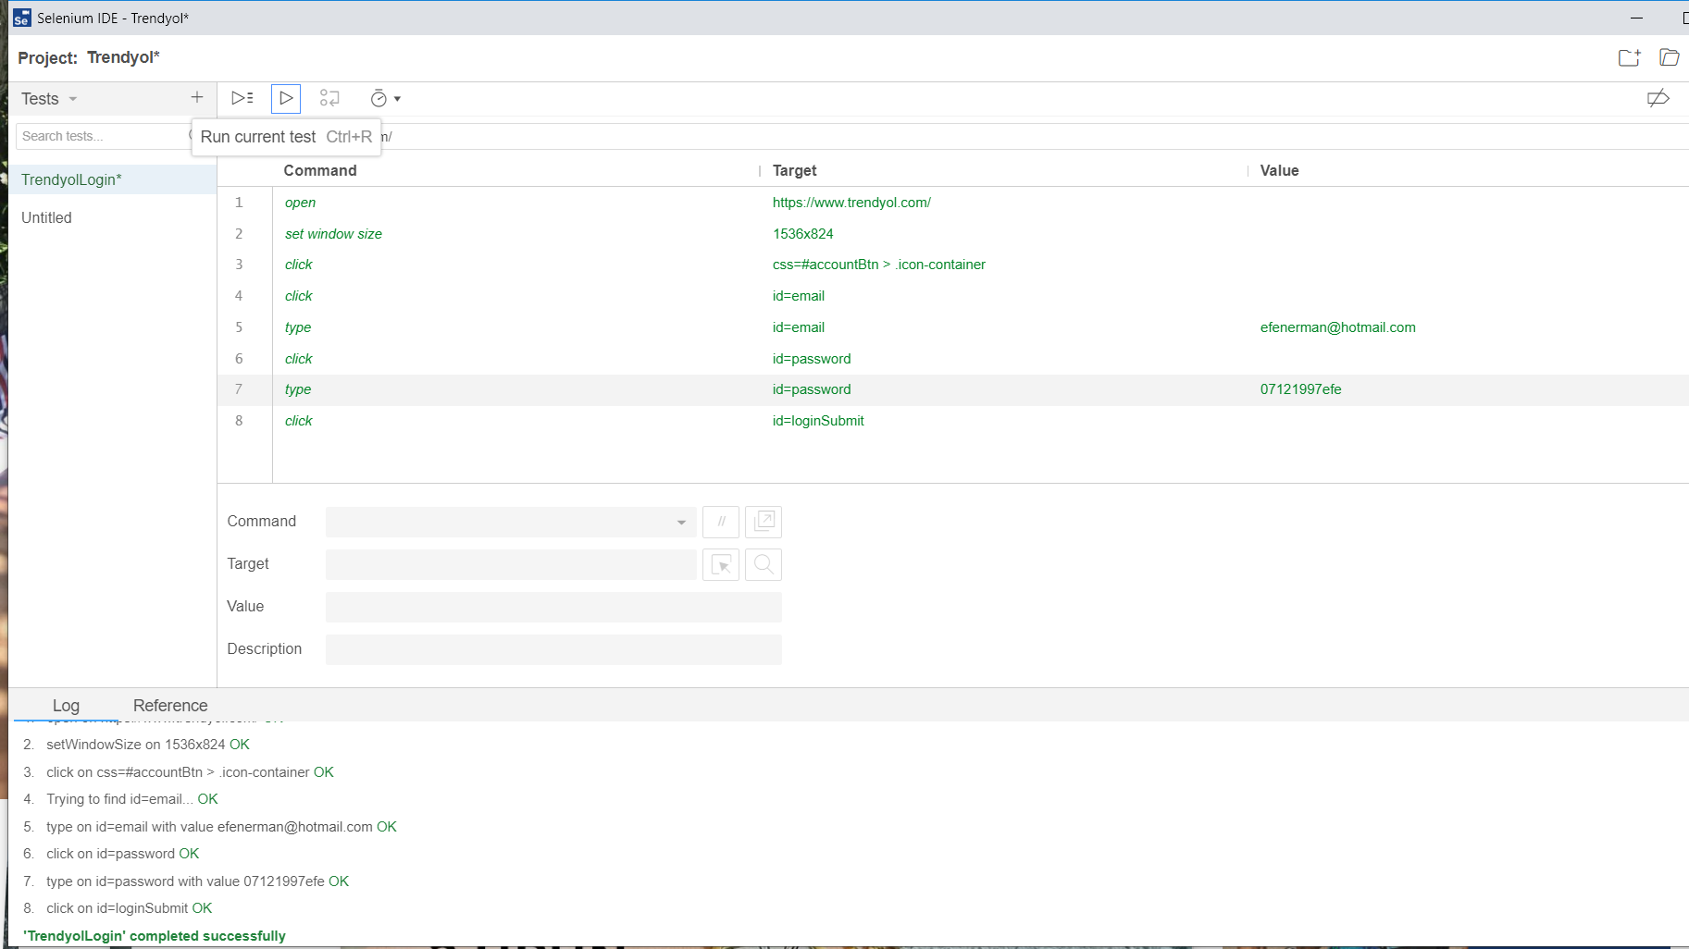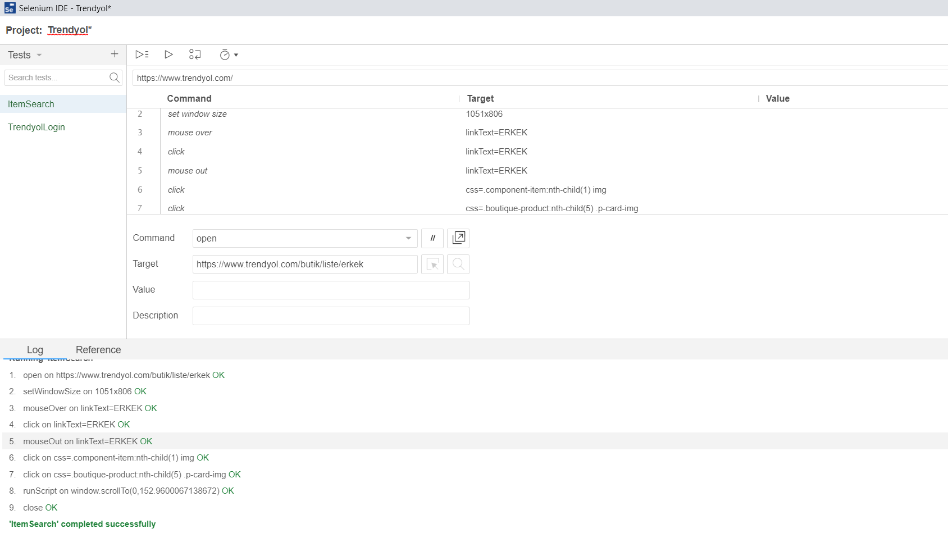

Item Search Test



Item Filter Test

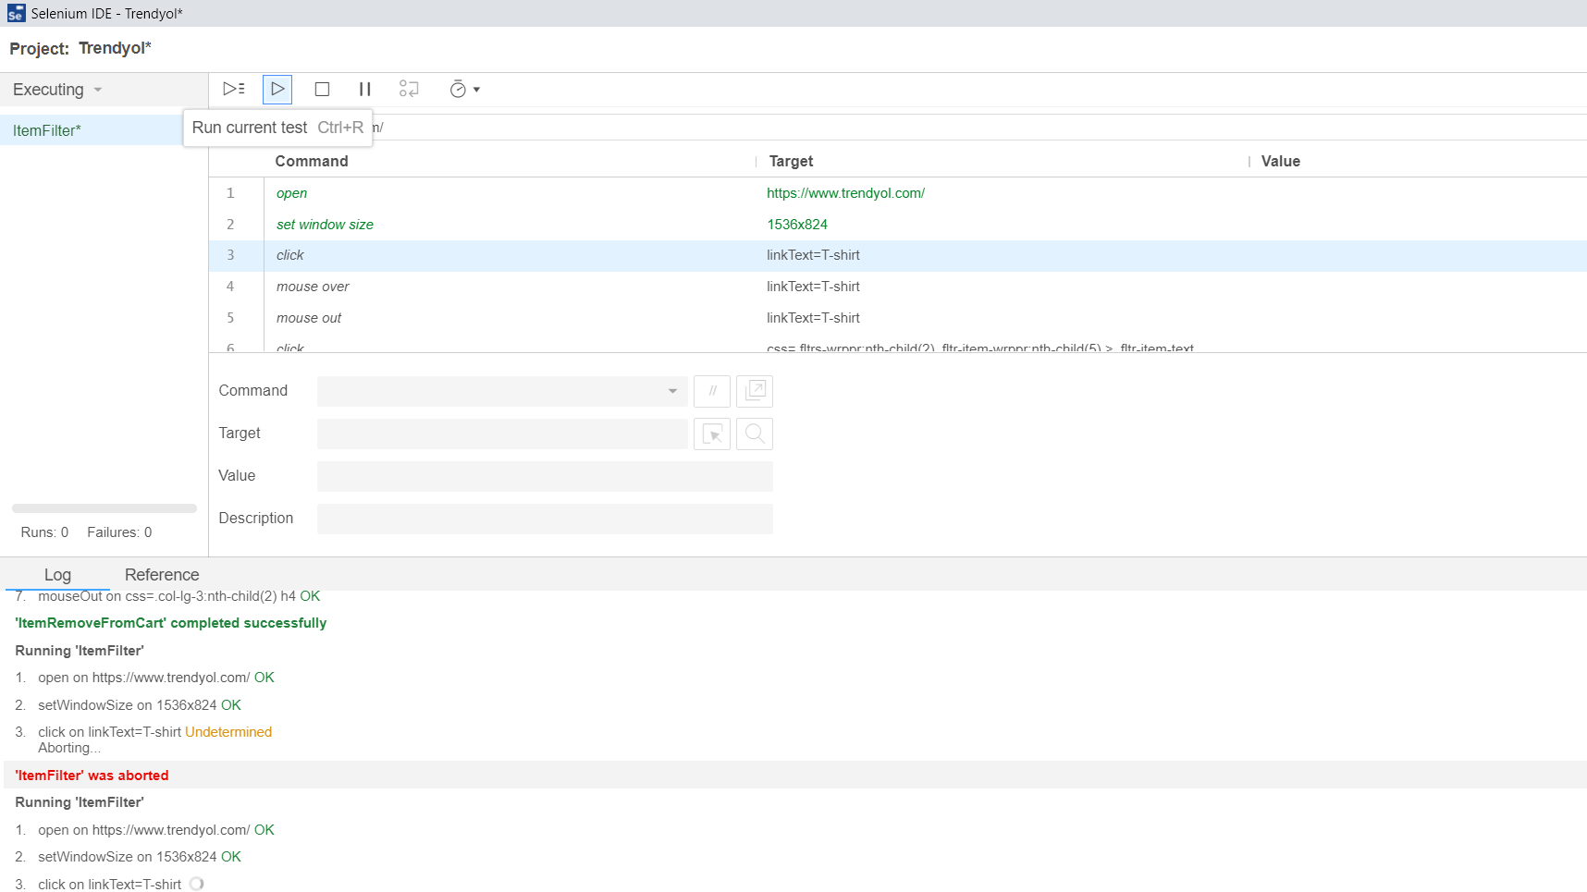

Item Add To Cart Test

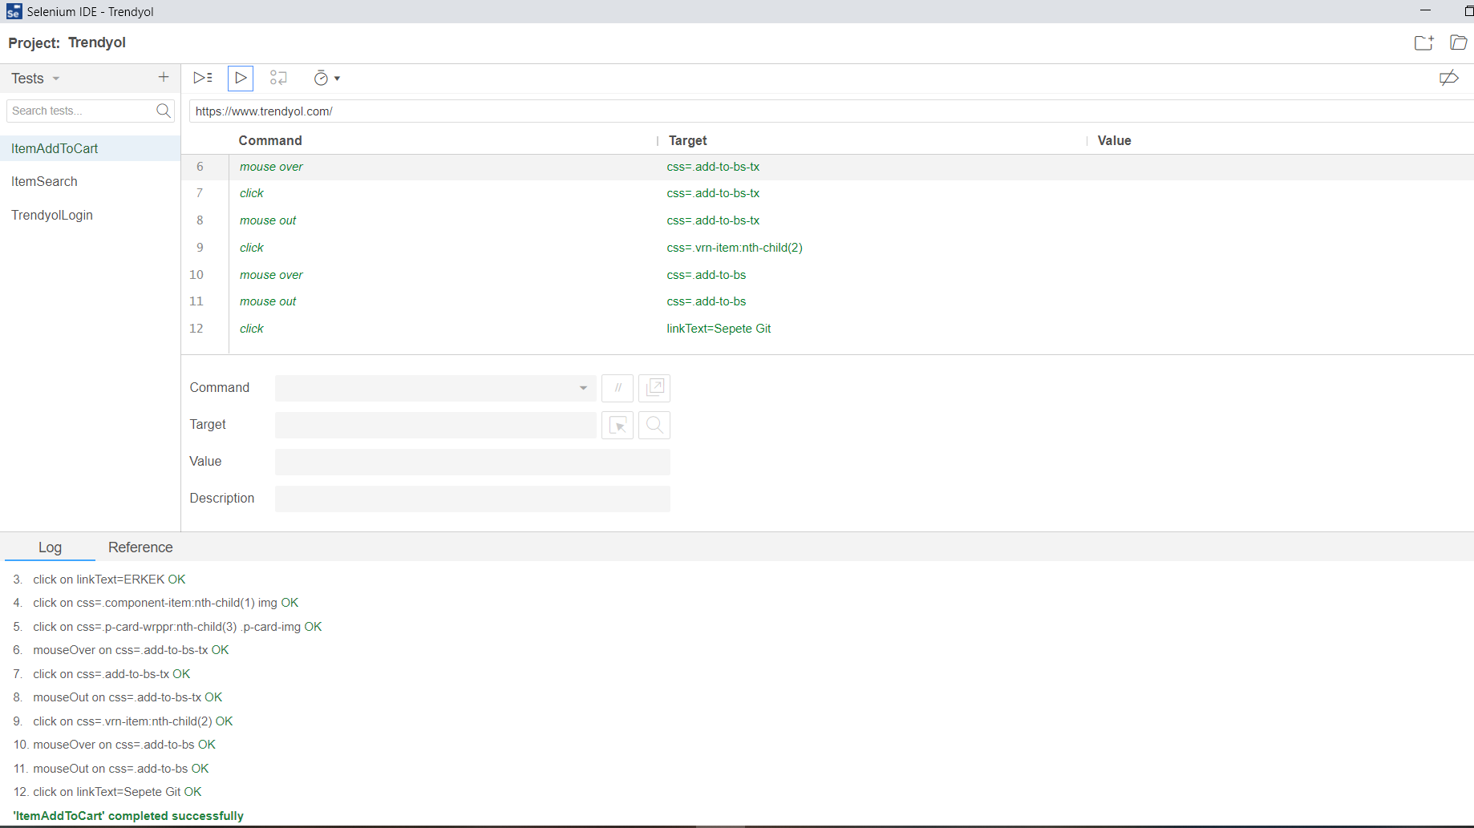

Item Remove From Cart

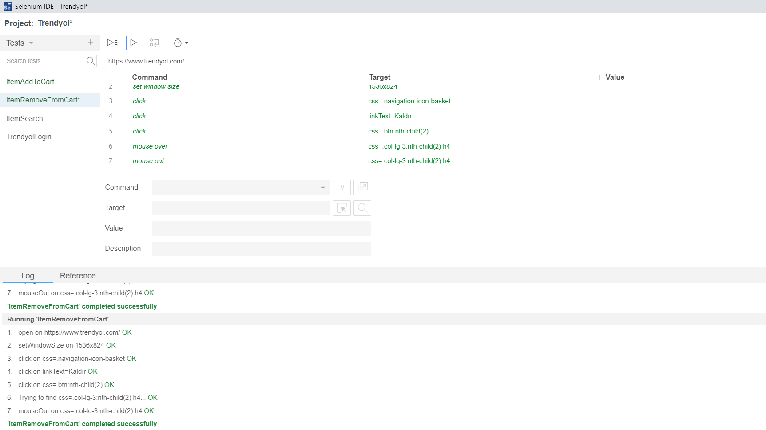

As a result, I saw that a large part of the site was working correctly in line with the tests I did.

As you can see the test results above

All tests were successful except filtering

I should mention that there is a site that usually has the capacity to meet your needs.